Lab 43-1 | Creating Assignment Rules
Objective: To create an assignment rule that assigns sales data to positions. |  |  20-25 minutes

NOTE: This lab aims at understanding how to create an assignment rule. Created assignment rules cannot be tested in Sample, as it requires the server component Assignment Manager.

Instructions:
It is common in many sales organizations to assign sales data such as accounts and opportunities to sales teams based on geography. In this lab you will create a rule that assigns eastern accounts to the CH 2210 - Sales Rep - West and CH 2220 - Sales Rep - East positions. For the purposes of this lab eastern accounts means accounts in the states of New York (NY), New Jersey (NJ), and Pennsylvania (PA).

- Double-click on the Siebel Call Center shortcut on the desktop. Login as SADMIN/SADMIN connecting to Sample database.

- You will create an assignment rule group for a small set of sales assignment rules you will create in this and subsequent labs.
- Navigate to Administration - Assignment > Rule Groups List using the Site Map.
- Create a new rule group with Name: Sales Rules Group

3. You will create an assignment rule that assigns eastern accounts.
- Drill down on the Sales Rules Group to navigate to the Assignment Rules list for this group.
- Create a new assignment rule with the following values:

Name | Assign East Accounts
Object to be Assigned | Account

The Account value is entered as follows:
    - Click the select button in the Object to be Assigned field.
    - Click New in the Assignment Object window.
    - Select Account from the drop-down.
    - Click Save.
    - Click OK.

- Drill down on Assign East Accounts to navigate to the Assignment Rule form applet.
- If necessary, set the Person Candidates Source to From Rule. This specifies that Assignment Manager consider only candidates explicitly listed in the rule.

4. You will now create the criteria that assign accounts in the eastern states.
  - If necessary, click the Criteria tab.
  - In the Criteria list applet, create a record with:

Rule Criterion | Account State
Comparison Method | Compare to Object
Inclusion | Include
Required | Always

  - Observe that the list applet below the criteria list applet displays two columns Score and State. Enter three State records as follows, leaving the Score field blank.
Score | State
 | NY
 | NJ
 | PA

- Click the Position Candidates view tab and add the following positions to specify the candidates to be considered for assignment in this rule.

Position
CH 2210 - Sales Rep - West
CH 2220 - Sales Rep - East

6. You will next activate the rule to make it available for use.
- Navigate to the Assignment Rules List view.
- Click Release, and click OK to dismiss the confirmation dialog. This updates the rules cache with all the currently active rules.

Lab 43-2 | Creating Assignment Rules for Service Data
Objective: To create an assignment rule that assigns service data to qualified employees. |  |  10-15 minutes

NOTE: This lab aims at understanding how to create an assignment rule. Created assignment rules cannot be tested in Sample, as it requires the server component Assignment Manager.

Instructions:
Organizations have many ways to assign service requests to service representatives. In this lab you will create an assignment rule that assigns a request for service (for a product) to a representative that is skilled in the associated product line.

- The product administrator has already created a set of products and product lines. You will examine them to become familiar with them, as you will use them in creating assignment rules and service requests.
  - Navigate to Administration - Product > Product Lines.
  - Verify that these three product lines exist.

Digital Cameras & Accessories
GSM Phones
RT - Video

You will use these product lines in creating assignment rules.
  - Navigate to Administration - Product > Products.
  - Query for products that belong to any of the above product lines (Cameras, Phones, or Video). You will use these products in creating Service Requests.

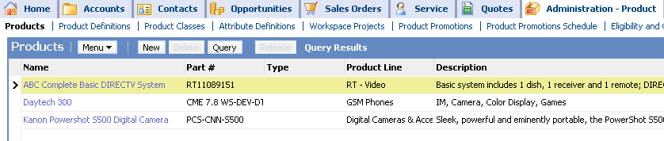

2. A set of four employees has also been created for the purposes of this lab. They have been assigned positions of Service Rep or Service Manager.
- Navigate to Administration - User > Employees.
- Query for employees whose Position has the string “Customer Service Rep” or the string “Customer Service Manager”.

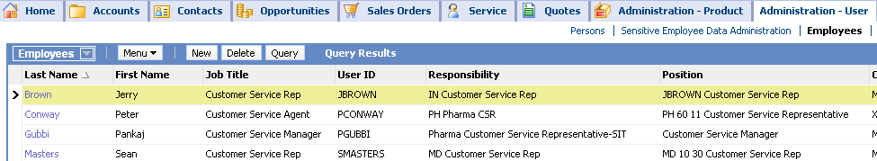

- You will create assignment rules based on employee skills. You will add a skill attribute to an employee.
  - Select and drill down on the Jerry Brown employee record (drill down on his last name, Brown).
  - In the Assignment Skills list applet, create a new record with Skill: Product Line.
  - Observe that the Assignment Skill Items applet below displays two columns named Product Line and Expertise. Create a new record in this applet with:

Product Line | Digital Cameras & Accessories
Expertise | Intermediate

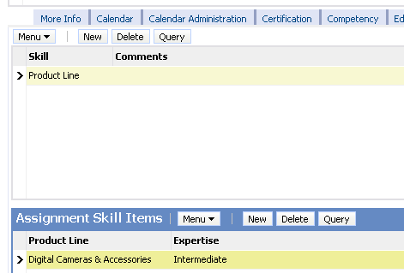

  - Set the skill attributes for the remaining employees as mentioned in the table below.

Employee User ID | Skill | Product Line | Expertise
PCONWAY | Product Line | GSM Phones | Novice
SMASTERS | Product Line | RT Video | Expert

Note that Pankaj Gubby is the Service Manager, and will not be automatically assigned to a service request. Therefore no skills have been defined for Marion.

- You are now ready to create a rule to assign service requests to the employee with the appropriate product line skill set.
  - Navigate to Administration - Assignment > Rule Groups List
  - Create a new rule group with Name: Service Rules Group

- You will create an assignment rule that assigns service requests based on product line.
  - Drill down on the Service Rules Group to navigate to the Assignment Rules list applet for this group.
  - Create a new assignment rule with the following values:

Name | Assign Service Request by Product Line
Object to be Assigned | Service Request

  - Drill down on Assign Service Request by Product Line to navigate to the Assignment Rule form applet.
  - If necessary, set the Person Candidates Source to From Rule.
  - Set the Assignee Filter to One, Random. This selects only one qualified employee at random to be assigned to the request.

6. In the Criteria list applet, add product criteria to the Service Request by Product Line rule using the following values:

Rule Criterion | Product Line
Comparison Method | Compare Object to Person
Inclusion | Include
Required | Always

Note: Compare Object to Person is used here to compare the object, Service Request, to attributes of person candidates; in this case, skill sets.

- To prevent Assignment Manager from considering all employees in the database, you will explicitly specify in the rule the employees to be evaluated.
- Click the Employee Candidates tab.
- Add the seven employees you identified at the beginning of this lab in the Administration – User > Employees view.

8. You will next activate the rule to make it available for use.
- Navigate to the Assignment Rules List view.
- Click Release, and click OK to dismiss the confirmation dialog.

